**18CS2053 – Web Technology Lab**

**[URK20CS2039]**

|  |  |
| --- | --- |
| **Ex. No. 8** | **Working With AngularJS Directives** |
| **Date of Exercise** | **10/10/2022** |
| **Web Host Link** | https://github.com/Jeevansiddhartha/web-tech/tree/main/ex8/ |
| **Youtube Link** | https://youtu.be/EbnTdZGR9lU |

Aim:

AngularJS is an open JavaScript framework developed and maintained by Google. It

implements the MVC (Model View Controller) pattern to separate data, presentation and logical components.



# Description:

AngularJS Architecture Angular.js follows the MVC architecture, the diagram of the MVC framework as shown below.

* The Controller represents the layer that has the business logic. User events trigger the functions which are stored inside your controller. The user events are part of the controller.
* Views are used to represent the presentation layer which is provided to the end users.
* Models are used to represent your data. The data in your model can be as simple as just having primitive declarations. For example, if you are maintaining a student application, your data model could just have a student id and a name. Or it can also be complex by having a structured data model. If you are maintaining a car ownership application, you can have structures to define the vehicle itself in terms of its engine capacity, seating capacity, etc.

# Create your first "Hello world" application in AngularJS.

<!DOCTYPE html>

<html lang="en"> <head>

<meta charset="utf8">

<title>Guru99</title>

</head>



Ex. 8 | Angular JS

1



**18CS2053 – Web Technology Lab**

**[URK20CS2039]**

<body ng-app="app">

<h1ng-controller="HelloWorldCtrl">{{message}}</h1>

<script src="https://code.angularjs.org/1.6.9/angular.js"></script>

<script>

angular.module("app",[]).controller("HelloWorldCtrl", function($scope) {

$scope.message="Hello World"

</script>

</body>

</html>

# Code Explanation:

* The "ng-app" keyword is used to denote that this application should be considered as an angular js application. Any name can be given to this application.
* The controller is what is used to hold the business logic. In the h1 tag, we want to access the controller, which will have the logic to display "HelloWorld", so we can say, in this tag we want to access the controller named "HelloWorldCtrl".
* We are using a member variable called "message" which is nothing but a placeholder to display the "Hello World" message.
* The "script tag" is used to reference the angular.js script which has all the necessary functionality for angular js. Without this reference, if we try to use any AngularJS functions, they will not work.
* "Controller" is the place where we are actually creating our business logic, which is our controller. The specifics of each keyword will be explained in the subsequent chapters. What is important to note that we are defining a controller method called 'HelloWorldCtrl' which is being referenced in Step2.
* We are creating a "function" which will be called when our code calls this controller. The $scope object is a special object in AngularJS which is a global object used within Angular.js. The $scope object is used to manage the data between the controller and the view.
* We are creating a member variable called "message", assigning it the value of "HelloWorld" and attaching the member variable to the scope object.

**NOTE:** The ng-controller directive is a keyword defined in AngularJS (step#2) and is used to define controllers in your application. Here in our application, we have used the ng-controller keyword to define a controller named 'HelloWorldCtrl'. The actual logic for the controller will be created in (step#5). If the command is executed successfully.



Ex. 8 | Angular JS

2



**18CS2053 – Web Technology Lab**

**[URK20CS2039]**

# Output:

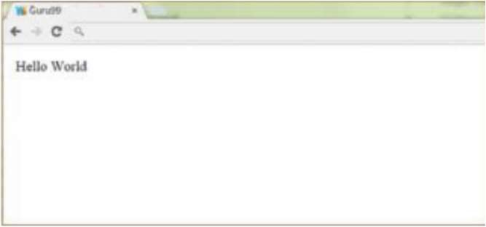

**Sample Programs: Question 1:**

Simple Comment Box using controller:

# Program:

<!DOCTYPE html>

<html>

<head>

<title>Experiment - 8</title>

<meta charset="UTF-8">

<meta http-equiv="X-UA-Compatible" content="IE=edge">

<meta name="viewport" content="width=device-width, initial-scale=1.0">

<link href="[https://cdn.jsdelivr.net/npm/bootstrap@5.2.0/dist/css/bootstrap.min.css](https://cdn.jsdelivr.net/npm/bootstrap%405.2.0/dist/css/bootstrap.min.css)" rel="stylesheet"

integrity="sha384-gH2yIJqKdNHPEq0n4Mqa/HGKIhSkIHeL5AyhkYV8i59U5AR6csBvApHH Nl/vI1Bx" crossorigin="anonymous">

<script src="[https://cdn.jsdelivr.net/npm/bootstrap@5.2.0/dist/js/bootstrap.bundle.min.js](https://cdn.jsdelivr.net/npm/bootstrap%405.2.0/dist/js/bootstrap.bundle.min.js) "

integrity="sha384-A3rJD856KowSb7dwlZdYEkO39Gagi7vIsF0jrRAoQmDKKtQBHUuLZ9As Sv4jD4Xa" crossorigin="anonymous"></script>

<script type="text/javascript" src="<http://ajax.googleapis.com/ajax/libs/angularjs/1.0.7/angular.min.js>"></scrip t>

</head>

<body class="bg-dark text-white">

<div class="container-fluid" ng-app="" >

<h1 class="text-center text-primary ">Experiment-8</h1>

<div class="d-flex justify-content-center text-center p-3">

<div ng-controller="FrmController" class="row border col-md-6 p-3">



Ex. 8 | Angular JS

3



**18CS2053 – Web Technology Lab**

**[URK20CS2039]**

<h3>Post your Comment </h3>

<form class="border p-3">

<textarea ng-model="txtcomment" class="col-sm-10 form-control" placeholder="Enter Comment..." ></textarea> <br><br>

<button ng-click='btn_add()' class="btn bg-secondary text-white">Post Comment</button>

</form>

<ul >

<h4>Comments</h4>

<li class="com-sm-4 text-start" ng-repeat="comnt in comment"> {{comnt}}

<button class="btn bg-secondary text-white m-4" ng- click="remItem($index)">Remove

comment</button></li>

</ul>

</div>

</div>

<div class="d-flex justify-content-center p-3">

<div class="row border col-md-4 p-3" ng- controller="CalculatorController">

<h3 class="text-center">Calculator</h3>

<form class="col-sm-10 ">

<label for="a">Enter the First Number</label><br>

<input class="form-control" type="number" ng-model="a" id="a" placeholder="Enter number..."><br>

<label for="b">Enter the Second Number</label><br>

<input class="form-control" type="number" ng-model="b" id="b" placeholder="Enter number..."><br>

<div class="col-sm-6 ">

<label for="operator">Operator</label>

<select class="form-select text-center " id='operator' ng- model="operator"

ng-init="operator='None'">

<option selected disabled hidden>None</option>

<option >+</option>

<option>*</option>

<option>-</option>

<option>/</option>

</select>

</div><br>

<p>{{ result() }}</p>

</form>

</div>



Ex. 8 | Angular JS

4



**18CS2053 – Web Technology Lab**

**[URK20CS2039]**

</div>

<div class="d-flex justify-content-center p-3">

<div class="row border col-md-6 p-3 text-center" ng- controller="ToDoController">

<h3>To Do List</h3>

<form class="form-control bg-dark ">

<input class="form-control" ng-model="title" placeholder="Enter task..."><br>

<button class="btn bg-secondary text-white" ng-click="add()">Add</button>

</form>

<h5 class="pt-4">Tasks Pending:</h5>

<ul class="text-start">

<li ng-repeat="t in tasks">{{t}} <button class="btn bg-secondary text-white m-4"

ng-click="DoneTask($index)">Remove comment</button></li>

</ul>

</div>

</div>

<script type="text/javascript"> function FrmController($scope) {

$scope.comment = [];

$scope.btn_add = function() { if($scope.txtcomment !=''){

$scope.comment.push($scope.txtcomment);

$scope.txtcomment = "";

}}

$scope.remItem = function($index) {

$scope.comment.splice($index, 1);

}}

function CalculatorController($scope) {

$scope.result = function() { CalculatorController.renderUnknownOption = angular.noop; if($scope.a !=undefined && $scope.b !=undefined ){

if ($scope.operator == '+') { return $scope.a + $scope.b; } if ($scope.operator == '-') {

return $scope.a - $scope.b; } if ($scope.operator == '*') {

return $scope.a * $scope.b; } if ($scope.operator == '/') { return $scope.a / $scope.b; }

}



Ex. 8 | Angular JS

5



**18CS2053 – Web Technology Lab**

**[URK20CS2039]**

else{

return "Fill Both Fields"

}}}

function ToDoController($scope){

$scope.tasks = [];

$scope.add = function() { if($scope.title !=''){

$scope.tasks.push($scope.title); }

}

$scope.DoneTask = function($index) {

$scope.tasks.splice($index, 1);

}

}

</script>

</body>

</html>

# OUTPUT:



Ex. 8 | Angular JS

6



**18CS2053 – Web Technology Lab**

**[URK20CS2039]**

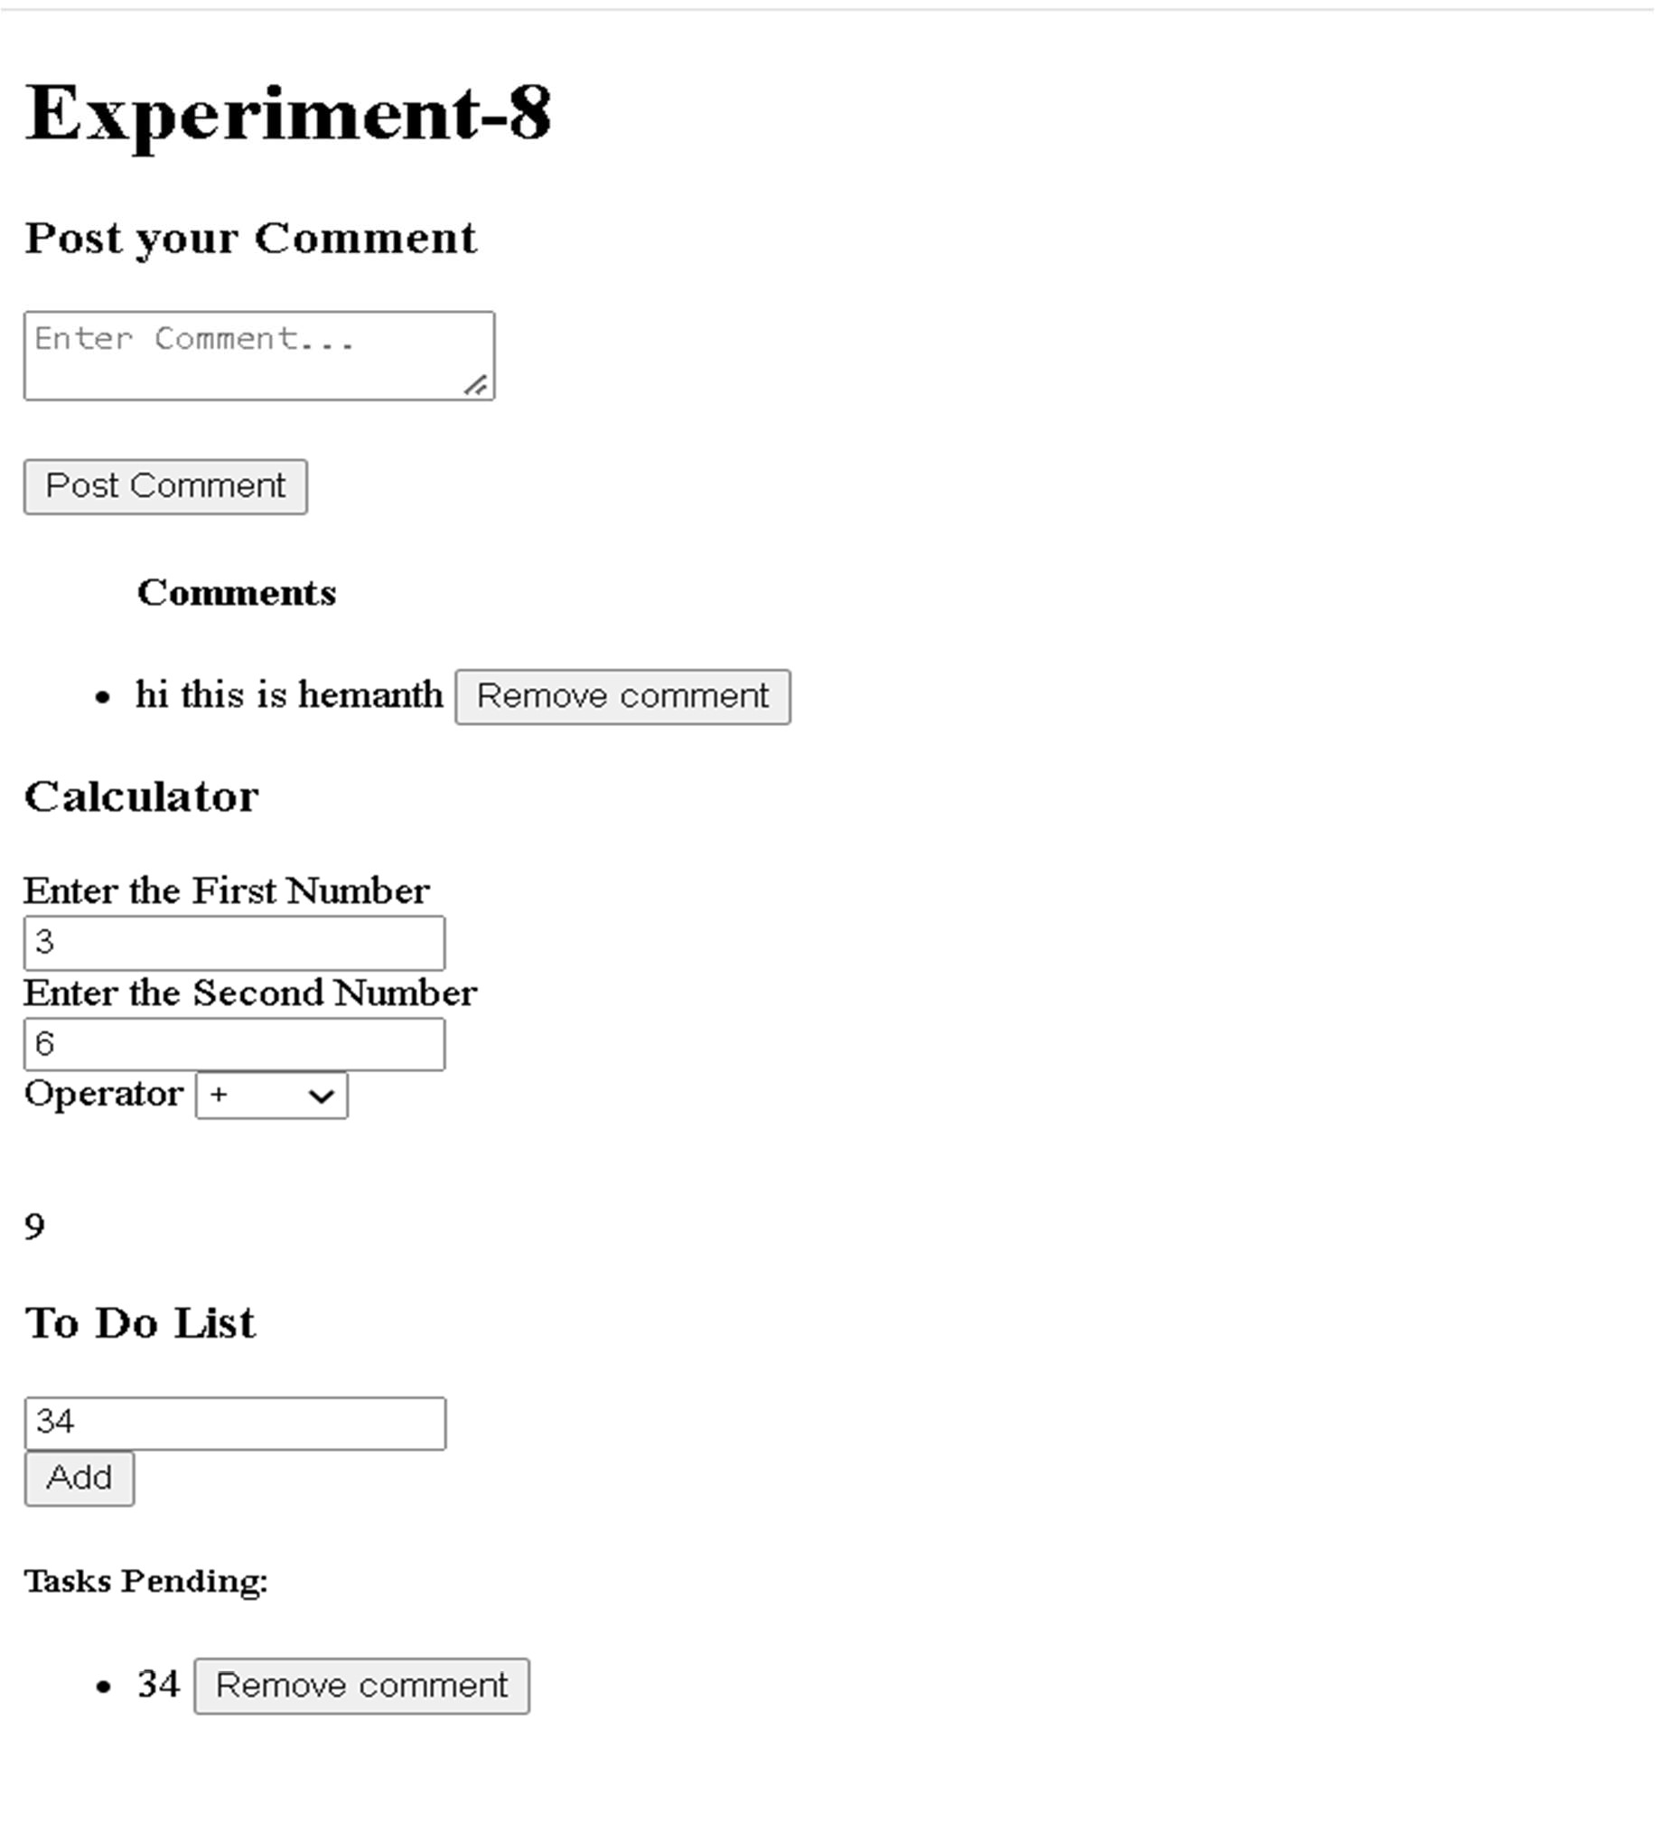

**Result:**

The above program is executed and verified successfully.



Ex. 8 | Angular JS

7